Module Name: Login Page - Functional & UI Test Case
Test Case ID: TC_LOGIN_001
Webpage URL: https://opensource-demo.orangehrmlive.com/web/index.php/auth/login

Scenario ID: 1A
Scenario: Login with valid credentials
Test Steps:
- Open the OrangeHRM Login page
- Enter a valid username
- Enter a valid password
- Click on Login
Screenshots : 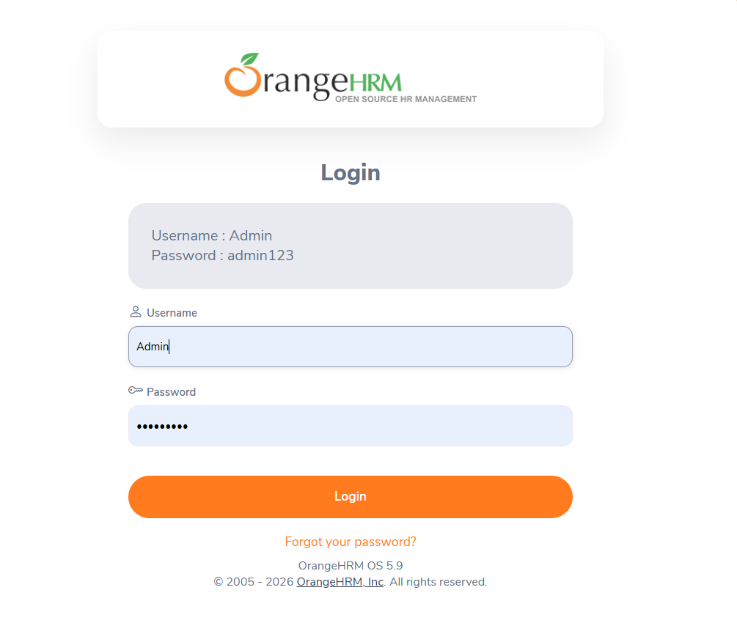

Scenario ID: 2A
Scenario: Login invalid credential
Test Steps:
- Open OrangeHRM Login page
- Enter an invalid username
- Enter an invalid password
- Click on Login
Screenshots :
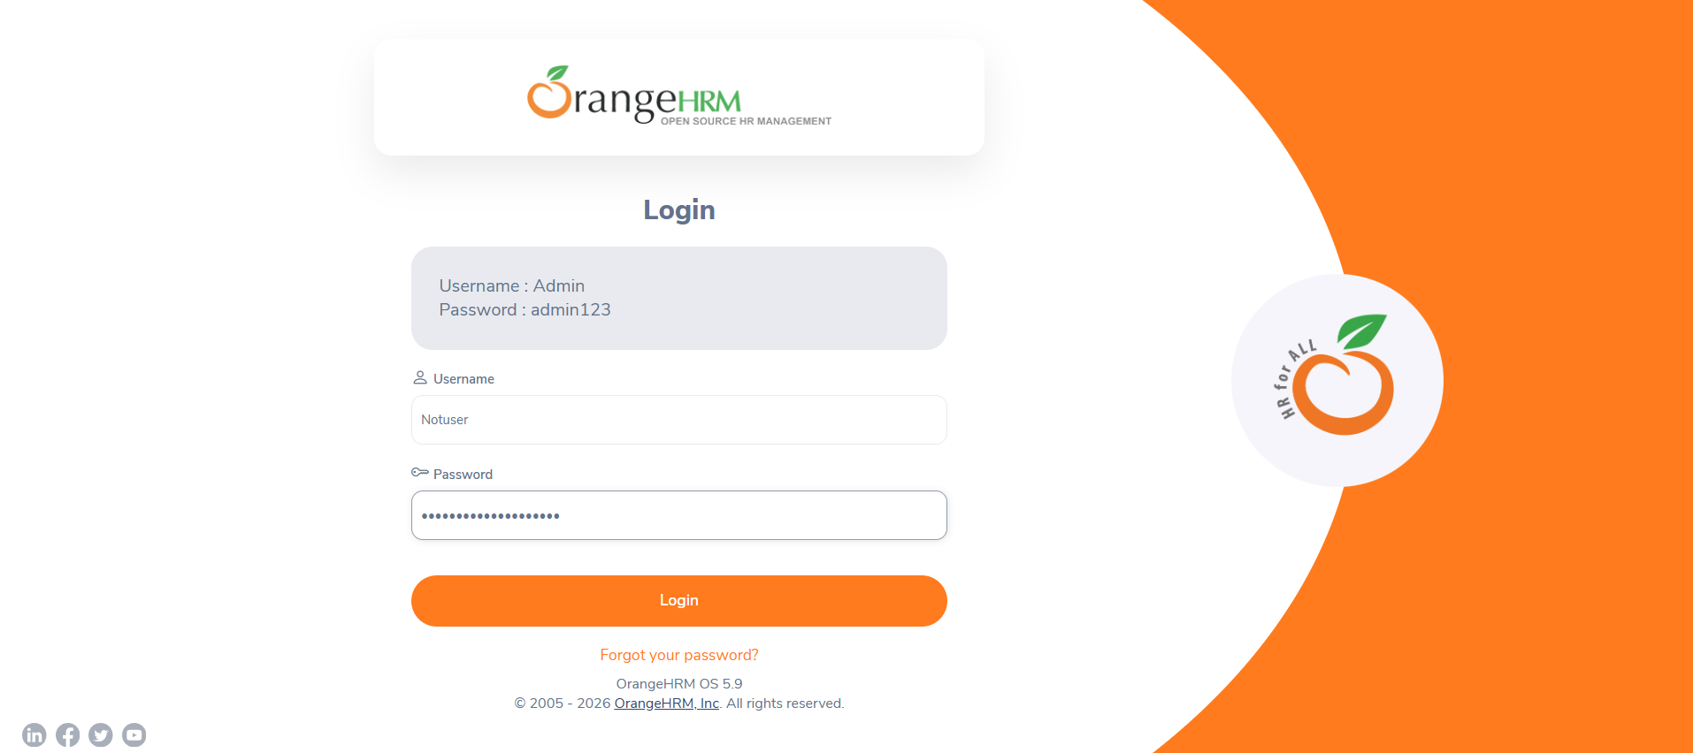

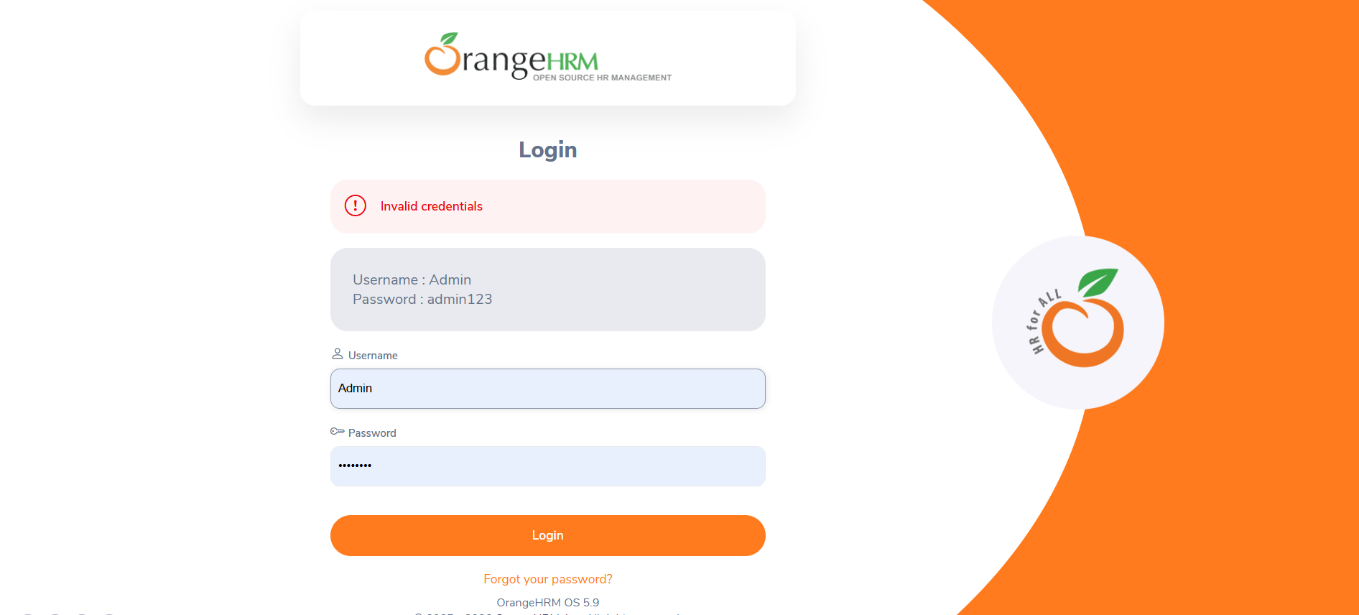

Scenario ID: 2B
Scenario: Login with empty username and password
Test Steps:
- Open OrangeHRM Login page
- Leave username blank
- Leave password blank
- Click on Login
Screenshots :
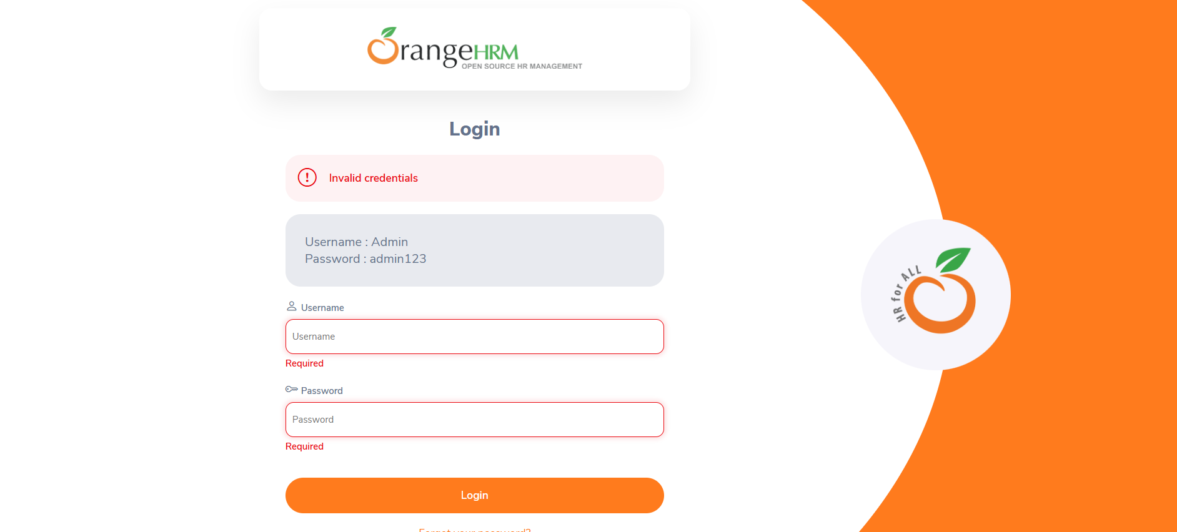

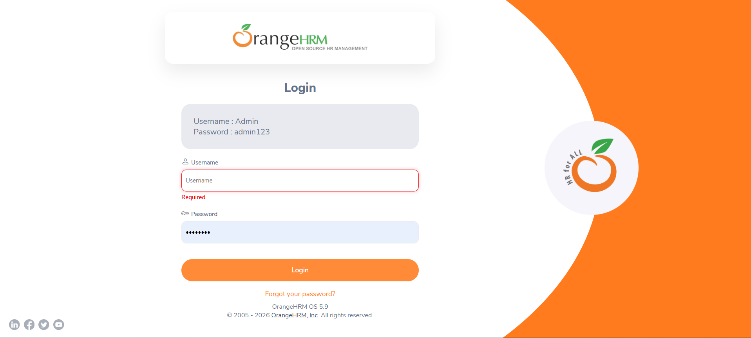

- Scenario ID: 3A
Scenario: Login page UI investigation
Test Steps:
- Open OrangeHRM Login page
- Login with valid credentials
- Click login button
- Dashboard shown
Screenshots :

